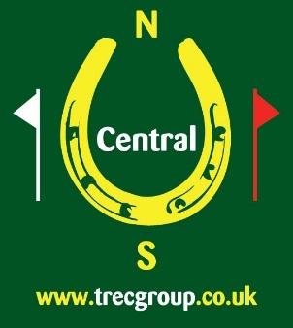
CENTRAL TREC GROUP
PTV TRAINING
Sunday 20th October 2018
Low Farm, Bozeat, Wellingborough, Northamptonshire, NN29 7NO
Enquiries to Sally Elliott – central@trecgroup.co.uk
A great opportunity to find out more about the sport of TREC or to practice your existing skills
Sessions will be either “Have a Go” at obstacles or
Receive instruction from Eva Green on how to ride the obstacles more effectively to achieve better marks
- Have instruction and practice PTV obstacles (S-Bend, Rein Back, Corridor, etc)
- Sessions will be for 1 hour and will be in groups of no more than 4
For simply Having a Go at obstacles: Cost – CTG members £10, non-members £15
For the additional training: - CTG members £23, non members £25
Entry Form – Low Farm PTV Training
Name: .......................................………….................... Email ……………………………………………………………
Address..................................................................................................................................................
………………………......................................................................................................................................
Postcode: ............................................................. Tel No: ...............................................................
Mobile no: ……………….………………………………………
CTG member Y …. N …. Membership number ……………………………………………………
CTG vouchers enclosed to the value of £……………… (Voucher numbers ……………………………………)
Cheque (made payable to Central TREC Group) enclosed for £………….

Prefer morning ………… afternoon ……… (please tick one) We cannot promise to meet all requests but will do our best to do so. Have a Go sessions will be the first and last of the day.
I would like to: Have a Go at obstacles
: Receive extra training

I understand that the non-member rate includes day membership of Central TREC Group.

Signed: ……………………………………………… Date: ………………………………………………

Post to: Sally Elliott, 91 Spinney Hill Road, Olney, Buckinghamshire, MK46 5AD OR Email form to central@trecgroup.co.uk and pay by BACS transfer (sort code 08 92 99, account number 65796977 [please note, this account number has recently changed], please use your name and ‘Low Farm’ as the reference) or PayPal (payments should be sent to paypal@trecgroup.co.uk).

