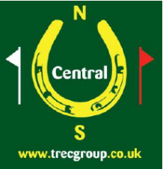
Tur Langton TREC
Competitors Information

Grid Ref SP 716 943
Postcode of Church in Village – LE8 0PJ
This Competition is in aid of
Tur Langton Village Hall Repair Fund

Emergency Numbers – Mary 07712 557721 (and enquiries beforehand). Helen 07979 594665 (wristbands will be provided)

The venue is a grass field without facilities.
There is plenty of room and grass. Horse water is available from a trough. Mains water (drinking quality) is available from a tap with somewhat difficult access.
Limited toilets will be available primarily for judges/helpers.

The Map Room will start at 11.15am and it is anticipated that all riders should complete their POR by 4.30pm.
Prize Giving is scheduled for 5pm (Level 1), 5.30pm (Levels 2 and 2A)

If you have booked corralling for Saturday night please would you confirm that you are still intending to do so.
Tur Langton has a very good pub opposite the Church (10 minutes walk from the field). If you would like to eat there the organiser will reserve a table or Fish and Chips could be brought in. Please complete and email the form attached.

Directions
Venue field is on B6047 between Church Langton and Tur Langton as per map below.

From North: Take B6047 from south from A47

From South: Take B6047 north from A6
