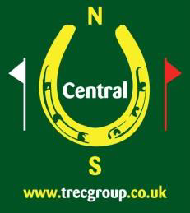
Central TREC Group
Anglesey Riding Holiday
Thursday 6th to Monday 10th June 2019
Porth-y-Post Farm, Trearddur Bay, Holyhead. LL65 2UP

Booking Form (Entries Close 7/5/19)
Name
Address

Email
Phone Numbers
CTG Membership no |  |  |  | TREC Experience Level
Arrival Day & Time
Departure Day
Vehicle | Lorry Trailer Caravan
Tent |  |  | Bed required in Bungalow (£60 extra)
Sharing with
Able to transport own horse during the holiday Yes No |  |  |  |  | Can offer lift to another  Yes No Name
Car for transport to supper / showers etc Yes No |  |  |  |  | Can offer lifts to ………. others
Any specific requirements

PAYMENT
Holiday £150 or £125 |  | Bed £60 |  |  | Flatwork£15 |  |  | Total
Paypal (to paypal@trecgroup.co.uk) with name
BACS to 08-92-99, a/c 65796977
Cheque to Central TREC Group enclosed for
Email to Anglesey@trecgroup.co.uk or
post to Mrs M.Weston(Anglesey), Carpenters House, Tur Langton, Leics LE8 0PJ

